**JUNIPER-CISCO OSPF LAB**

**Network Topology:**

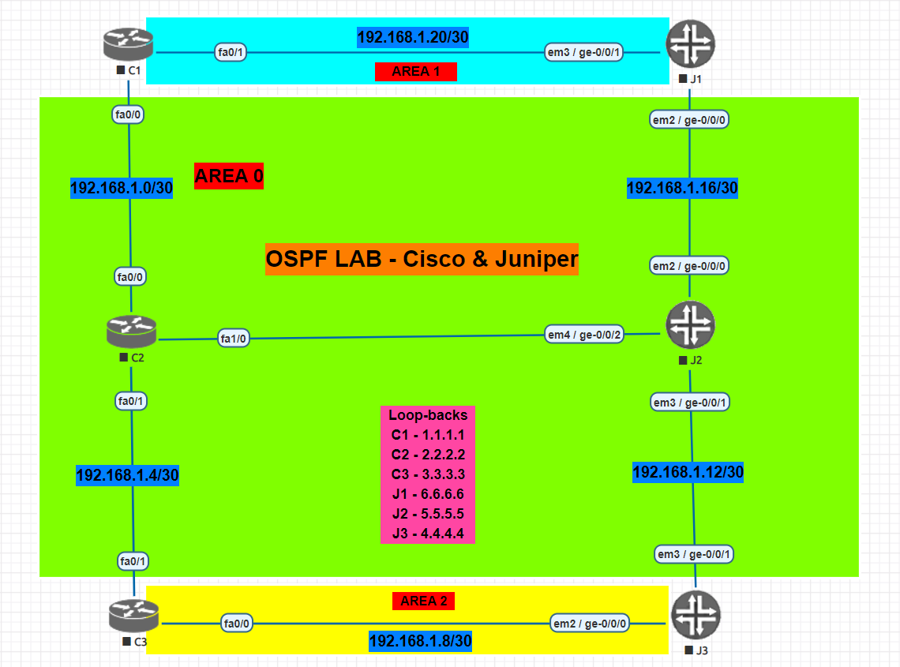

**NOTE: Perform All the basic configuration on Juniper Router before performing the lab**

* **In the above given topology, C2 and J2 routers belong to Area 0.**
* **C1 and J1 are ABR’s for Area 0 and Area 1.**
* **C3 and J3 are ABR’s for Area 0 and Area 2.**
* **All the 6 loopbacks are in Area 0.**

1. **Configure the respective physical interfaces & also configure the loopback interfaces on all the routers in the configuration mode as per the network topology**

**CISCO Routers:**

**C1:**

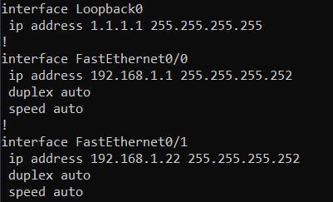

**C2:**

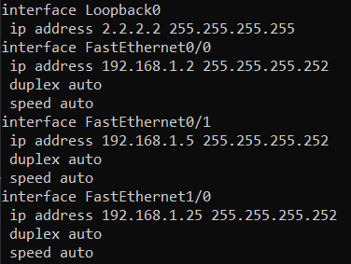

**C3:**

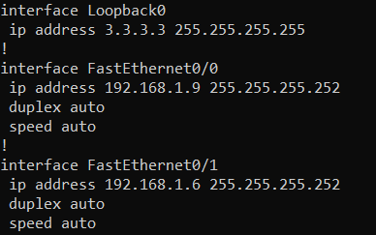

**JUNIPER Routers:**

**J1:**



**J2:**

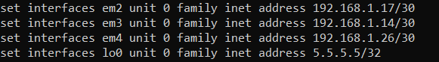

**J3:**

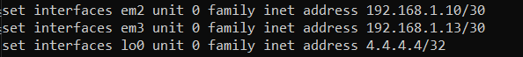

1. **Verify using the show command that all the interfaces are configured correctly.**

**CISCO Routers:**

**C1:**

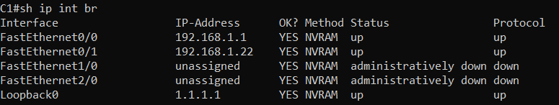

**C2:**

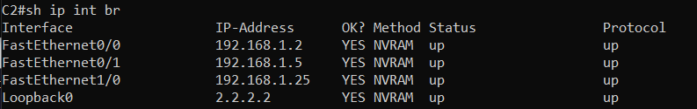

**C3:**

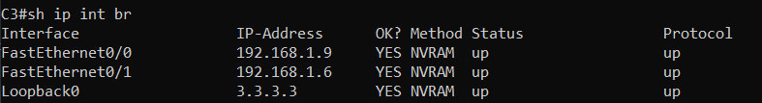

**JUNIPER Routers:**

**J1:**



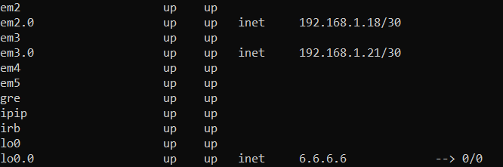

**J2:**



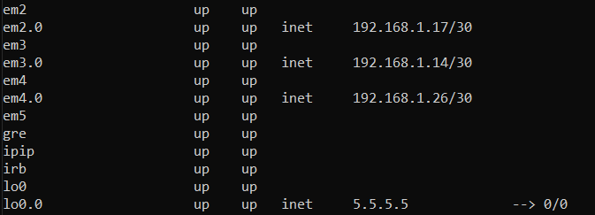

**J3:**



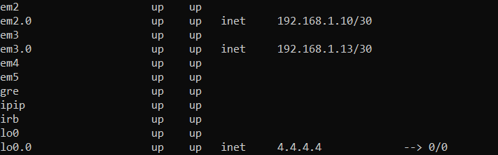

1. **Configure OSPF on all the Cisco Routers & advertise loopback 0 as Router ID.**

**CISCO Routers:**

**C1:**

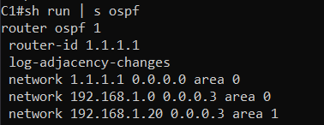

**C2:**

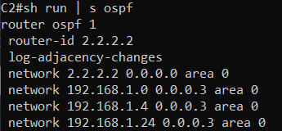

**C3:**

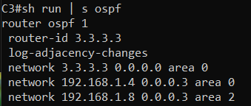

1. **Configure OSPF on all the Juniper Routers.**

**JUNIPER Routers:**

**J1:**



**J2:**

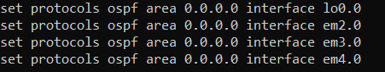

**J3:**

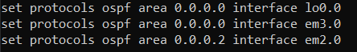

1. **Verify OSPF neighborship is formed**

**CISCO Routers:**

**C1:**

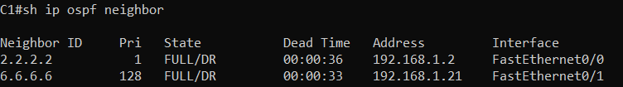

**C2:**

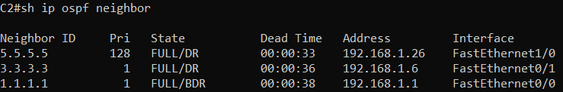

**C3:**

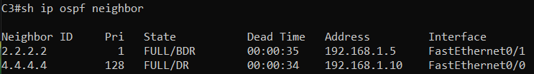

**JUNIPER Routers:**

**J1:**

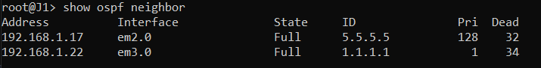

**J2:**

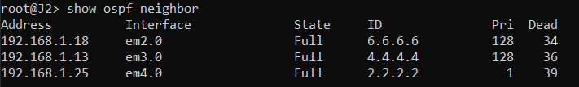

**J3:**

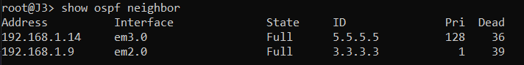

1. **Verify using the show command on both the Cisco & Juniper routers whether Routes learnt from OSPF is seen or not in the routing table.**

**CISCO Routers:**

**C1:**

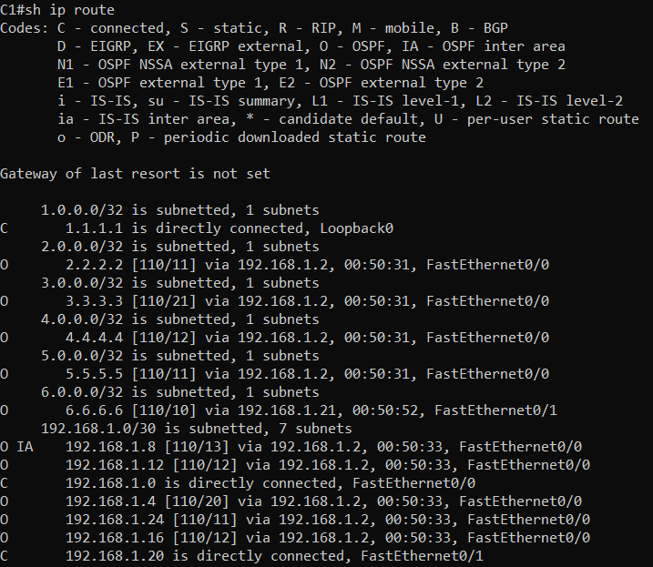

**JUNIPER Routers:**

**J1:**

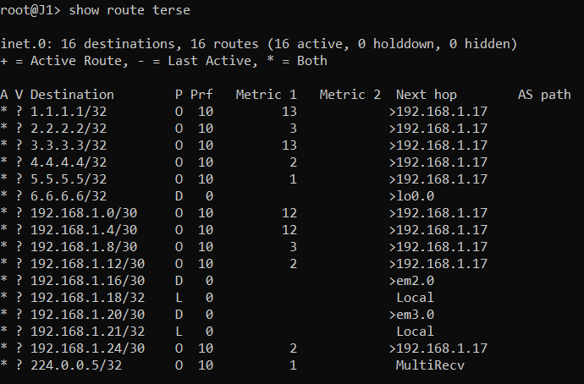

1. **Paste a screenshot of the command showing all the respective configurations done on the Cisco as well as Juniper router**

**CISCO Routers:**

**C1:**



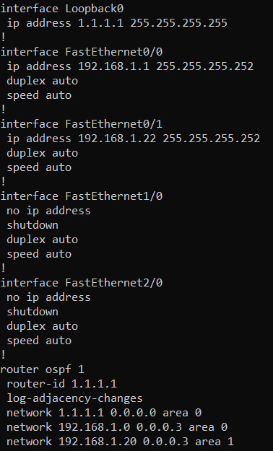

**JUNIPER Routers:**

**J1:**



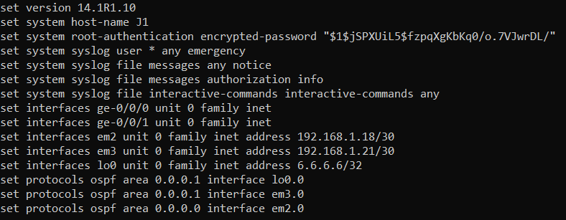

1. **Verify using the ping command to check the end to end connectivity from loopback of C1 to loopback of J3 & vice-versa.**

**C1 to J3:**

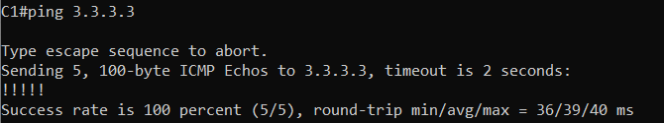

**J3 to C1:**

